LITURGY FOR FELLOWSHIP OF THE LEAST COIN
INGATHERING SERVICE
and FLC 60th ANNIVERSARY JUBILEE

Theme: “Let justice and peace embrace.” Psalm 85: 10
Preparation:
During this 60th Anniversary, let us share FLC with youth and children through the story Shanti Means Peace. Invite youth and children to this FLC Ingathering Service to sing the special song “A Bird Tells Me.” The chorus can have action of rolling the hands forward. If you have overhead projector, you can show the accompanying power point presentation of FLC and the list of projects to be supported by our prayers and least coins this year.
₊₊₊₊₊₊₊₊₊₊₊₊₊₊₊₊₊₊₊₊₊₊₊₊₊
Prelude
Entrance of Worship Leaders
Words of Welcome
Leader: It is with great pleasure that we are gathered today to seek Christian fellowship in prayer for one another and for those of other regions and countries. We now celebrate the 60th anniversary of Fellowship of the Least Coin which unites Christian women of the world in a fellowship of concern for each other, for creation and the whole household of God. Here we bring our symbols of this fellowship and our commitment to justice, peace and reconciliation—our Least Coins. God is good to have gathered us in this worship service.
Leader: The peace of Christ be with you.
All: And also with you.
(Everybody passes the peace of Christ to one another.)

*Call to Worship (stand)
Leader: Come! Praise God who created us and all of creation.
Whose faithfulness never ceases in assuring us the gift of life.
People: We praise you, O God of life!

Leader: Come! Remember God’s liberating acts in Jesus Christ!
In whose name we are all called to be God’s children,
By his mission and witness, we draw our collective mission and witness in today’s world.
People: We thank you, O Jesus Christ, for your mission of justice,
peace and reconciliation with which we are called to pray and do!

Leader: Come! Celebrate the sustaining presence of the Holy Spirit
by whose power and inspiration the Fellowship of the Least Coin was born in 1956 and which jubilee we now hold.
People: We celebrate the power of the Holy Spirit that unites us in
The Fellowship of the Least Coin.

*Opening Song: Called as Partners in Christ’s Service
(to the tune of Joyful, Joyful We Adore Thee)
Composer: John Zundel, 1870
Author: Jane Parker Huber, 1981
Called as partners in Christ’s service,
Called to ministries of grace,
We respond with deep commitment
Fresh new lines of faith to trace.
May we learn the art of sharing,
Side by side and friend with friend,
Equal partners in our caring
To fulfill God’s chosen end.

Christ’s example, Christ’s inspiring
Christ’s clear call to work and worth,
Let us follow, never faltering,
Reconciling folk on earth.
Men and women, richer, poorer,
All God’s people, young and old,
Blending human skills together
Gracious gifts from God unfold.

Thus new patterns for Christ’s mission,
In a small or global sense,
Help us bear each other’s burdens,
Breaking down each wall or fence.
Words of comfort, words of vision,
Words of challenge, said with care,
Bring new power and strength of action,
Make us colleagues, free and fair.

So God grant us for tomorrow
Ways to order human life
That surround each person’s sorrow
With a calm that conquers strife.
Make us partners in our living,
Our compassion to increase,
Messengers of faith, thus giving
Hope and confidence and peace.

Opening Prayer

Greetings for the FLC 60th Anniversary

Remembering the Vision of FLC (may be through dramatization or power point presentation or the book Shanti Means Peace)

Song Response:
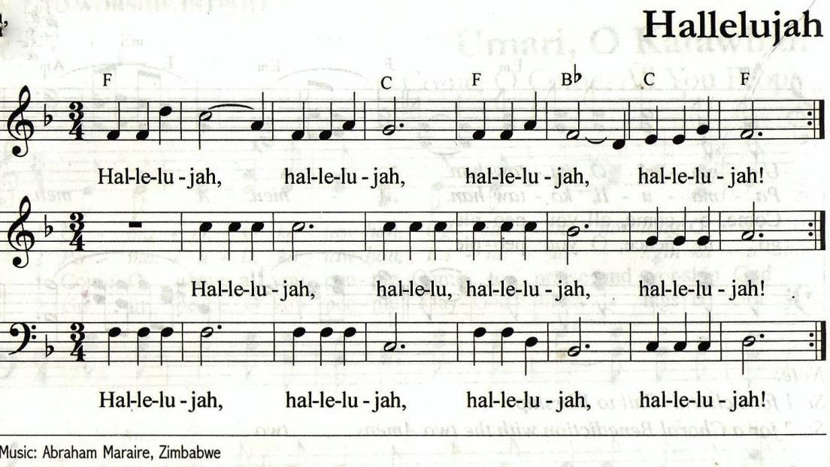

Bible Reading Psalm 85 The Coming Age of Peace and Justice
(Psalms Anew by Nancy Schreck and Maureen Leach)

Voice 1: Yahweh, you have favored your land
And restored the well-being of Israel;
You have forgiven the guilt of your people
And covered all their sins.
Voice 2: You set aside all your rage;
You calmed the heat of your anger,
Voice 1: Restore us now, God our Savior!
Put an end to your displeasure with us.
Voice 2: Will you be angry with us forever?
Will your anger never cease?
Will you not instead restore our life
That your people may rejoice with you?
Voice 1: Let us see your faithfulness
And give us your saving help.
Voice 2: I will hear what you, God, proclaim:
A voice that speaks of peace—
Peace for your faithful
And those who turn to you in hope.
Voices 1 and 2: Your salvation is near for those who fear you,
And your glory will dwell in our land
Love and faithfulness have met;
Justice and peace have embraced.
Voice 1: Faithfulness shall spring from the earth
And justice look down from heaven.
Voice 2: Yahweh, you will give what is good,
And our earth shall yield its fruit.
Voices 1 and 2: Justice shall march before you,
And peace shall follow your steps.

Silent Moment

Special Song A Little Bird Tells Me (to be sung by a Children’s Choir
or Youth Choir)
Message

Silent Reflection

Prayers of the People
Voice 1: God of justice and of peace.
you ask us to pray for all people.
Here we offer our prayers for a violent and hurting world,
trusting in your great love.

Let us pray for the church.

(Silence)

God of Truth, in a world which seeks security
by building walls and loading guns,
may your church boldly proclaim
an alternative vision of peace
which comes from justice and solidarity.

People: Hear our prayer, O God of Truth.

Voice 2: Let us pray for those who rule:

(Silence)

God of Wisdom, we pray for those
we have elected to public office,
and for political leaders everywhere,
that they may administer the tasks of government
with courage and equity,
and seek a strong voice for peace
and true human security.

People: Hear our prayer, O God of Wisdom.

Voice 3: Let us pray for those experiencing war:

(Silence)

God of Compassion, in Myanmar, Colombia, in Palestine and Israel, Ukraine, Syria, Iraq, Turkey, Sudan, and Ethiopia,
Pakistan, Bangladesh and India, United States of America,
in all regions of the world where your people suffer
from the violence of war and the violence of oppression,
open the way forward to hope, to healing,
to a just and lasting peace.
We name before you other regions and peoples
in need of peace. __________________________________.

People: Hear our prayer, O God of Compassion.

Voice 4: Let us pray for those experiencing violence in our own country:
(Silence)
God of Justice,
for Aboriginal peoples violated in their land rights,
for homeless persons violated in their right to shelter,
for women and children violated in their own home,
for migrants and refugees denied access to new opportunities,
for farmers experiencing hunger due to drought and climate change
we ask for freedom from fear and freedom from want.

People: Hear our prayer, O God of Justice.

Voice 5: Let us pray for seekers of a just peace.

(Silence)
God of Peace, we pray for courageous and committed people
around the world who every day take steps, small and large,
along the path to peace.
May we too be faithful travelers
as we follow in the footsteps of Jesus
who came to be our Peace.

People: Hear our prayer, O God of Justice.
(adapted from Cultivating Just Peace, Kairos Education for Action Guide 2003-4 Copyright Kairos)

Silence

Offering of FLC Contributions
Let us now offer our FLC Contributions to support women’s work for justice, peace and reconciliation all over the world. These least coins are symbols of forgiveness, love and concern for each other.

FLC Prayer (together)
O loving Creator, we present ourselves in your divine presence to thank you for all the bountiful gifts of life. We are especially grateful for the Fellowship of the Least Coin which binds us together in love and forgiveness around the globe. Free us from all doubts and prejudices, we pray. Inspire us to live in solidarity with humankind that we may know the joy of giving and receiving.
Dear God, accept the least coin “token of love.” Make us mindful of the miracles of these coins. Let us honor your creation with love, as shown through the life and resurrection of your son, Jesus the Christ. Amen.
FLC Hymn
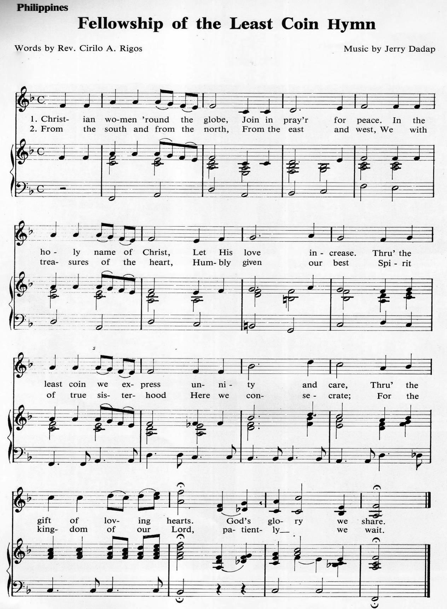

Blessing
May the blessing of the God of peace and justice be with us;
may the blessing of the Son who weeps the tears of the world’s suffering be with us;
and may the blessing of the Spirit who inspires us to reconciliation and hope be with us from now and eternity.
Amen.

Summary of Project Grants 2016

Asia
1. Project “Feminist Theological Consultation,” AWRC, US$5,000
2. Project “Sanitation and Hygiene Program,” Bangladesh, US$4,836
3. Project “Iwaki Food Radiation Measurement Project,” Japan, US$5,000
4. Project “Leadership Development Program for Women Ministers,” South Korea, US$5,000
5. Project Formation and Vitalization of Asian Church Women’s Ecumenical Movement,
ACWC, US$5,000
6. Project “Overcoming Violence against Women and Children,” CCA, US$5,000
7. Project “UTS Children’s Nature’s Park,” Philippines, US$5,000

Latin America
1. Project “Ancestral Mayan Arts Sales Integral Cooperative, LLC,” Guatemala, US$5,000
2. Project “Pastoral and Holistic Theological Circle,” El Salvador, US$5,000
3. Project “Dignity and Social Inclusion: Socially vulnerable children and youth,”
Rep. Argentina, US$5,000
4. Project “The kyriocéntrica culture and the ‘touches’ women receive,” Costa Rica,
US$ 5,000

Middle East
1. Project “Teenage Girls at Risk Program,” Lebanon, US$ 5,000
2. Project “ELCJHL Women’s Work,” Palestine, Jordan, Jerusalem, US$5,000
3. Project “Empowered by God,” Lebanon, US$5,000
4. Project “Rehabilitation and Sessions of Intensive Vocational Training at the
Central Women’s Prison in Baabda,” Lebanon, US$5,000

Europe
1. Project “Ecumenical Meeting and Sharing,” Greece and Cyprus, US$5,000
2. Project “Grandmother’s Gazebo Summer School”, Romania, US$5,000
3. Project “Awareness raising and preventing gender based violence,” Bosnia and
Herzegovina, US$5,000
4. Project “Young Women together in Pilgrimage,” Slovenia, US$5,000

USA
1. Project “Light up Zabuli Technical College!” Afghanistan, US$5,000
2. Project “Setting New Places in the Table”, USA, US$5,000

WDPIC
1. Project “Seeking wisdom to care for God’s creation,” for Pacific, US$5,000
2. Project “Seeking wisdom to care for God’s creation,” for Africa, Asia and Caribbean,
US$5,000

Africa
1. Project “Sustainable Sources of Income,” Liberia, US$5,000
2. Project “Young Egyptian Women as Agents of Peace Building and Consolidation,” Egypt,
US$5,000
3. Project “Reducing Discrimination and Violence against Women and Girls,” Benin,
US$5,000
4. Project “Awareness Creation on Gender Based Violence Crimes,” Tanzania, US$5,000
5. Project “Dairy Farming,” Kenya, US$5,000

Pacific
1. Project “Faithon Community Vegetable,” Papua New Guinea, US$3,000

